**COMPUTER SCIENCE**

**CLASS-XI (2020-2021)**

**ART INTEGRATION PROJECT**

**PYTHON PROGRAMME**

**THE ADDITION TUTORIAL**

**AIM-** To make the students practice the concept of addition of numerals up to Ten lakh place (7-digit numerals) using python language in a graded manner.

**OBJECTIVE –** To enhance theskill of programming using python language.

**HIGHTLIGHT** - This programme allows the student to choose any level for entry, exit and practice.

**METHODLOGY** – This programme is divided into 5 levels

1. Level-1 = Addition of 1-digit numbers
2. Level-2 = Addition of 2-digit numerals
3. Level-3 = Addition of 3-digit numerals
4. Level -5 = Addition of 4-to-7-digit numerals

**INPUT OF THE CODE -**

while True:

print(' The Addition Tutorial')

name=str(input('Enter your name-'))

print('Hi',name,'Welcome to addition tutorial by- Hirnika Oberoi')

print(''' Following are given the levels of the tutorial .Select one of them-

1. beginners’ level (for classes nursery to pre- primary) -1-digit addition

2. moderate level (for classes 1 to 2) -2-digit addition

3. high level (for classes 3 to 4)-3-to-4-digit addition

4. the advanced level(for higher classes)

5. exit the tutorial''')

level=int(input('Enter THE LEVEL WHICH YOU WANT TO PRACTICE(Enter the level no.eg=1,2) -'))

while level==1:

print(' Level-1')

a=int(input('Enter the no. of questions you want to practice -'))

n=0

for i in range(1,a+1):

import random

num1=random.randrange(1,10)

num2=random.randrange(1,10)

print(name,'solve',num1,'+',num2,'=')

sum1=num1+num2

ans1=int(input('ENTER ANSWER='))

if ans1==sum1:

n+=1

print('Woohhoo...your answer is correct.')

if i==5:

level=2

else:

print('OOPS! incorrect answer.The correct answer was',sum1)

print('Your score is ',n,'out of',a)

m=input('''Do you want to continue with is level ?

OR

Move to next level?

Write "yes"if you want to continue with this level OR 'no' to move to next level

OR

If you want to exit the module write '0'-''')

if m=='yes':

print('OK,there we go again')

level=1

elif m=='0':

level=0

else:

level=2

while level==2:

print(' Level-2')

b=int(input('Enter the no. of questions you want to practice -'))

o=0

for i in range(1,b+1):

import random

num3=random.randrange(1,100)

num4=random.randrange(1,100)

print(name,'solve',num3,'+',num4,'=')

sum2=num3+num4

ans2=int(input('ENTER ANSWER='))

if ans2==sum2:

o+=1

print('Woohhoo...your answer is correct.')

if i==5:

level=3

else:

print('OOPS! incorrect answer. The correct answer was',sum2)

print('Your score is ',o,'out of',b)

r=input('''Do you want to continue with is level ?

OR

Move to next level?

Write "yes"if you want to continue with this level OR 'no' to move to next level

OR

If you want to exit the module write '0' -''')

if r=='yes':

print('OK,there we go again')

level=2

elif r=='0':

level=0

else:

level=3

while level==3:

print(' Level-3')

c=int(input('Enter the no.of questions you want to practice-'))

p=0

for i in range(1,c+1):

import random

num5=random.randrange(1,1000)

num6=random.randrange(1,1000)

print(name,'solve',num5,'+',num6,'=')

sum3=num5+num6

ans3=int(input('ENTER ANSWER='))

if ans3==sum3:

p+=1

print('Woohhoo...your answer is correct.')

if i==5:

level=4

else:

print('OOPS! incorrect answer.The correct answer was',sum3)

print('Your score is ',p,'out of',c)

s=input('''Do you want to continue with is level ?

OR

Move to next level?

Write "yes"if you want to continue with this level OR 'no' to move to next level

OR

If you want to exit the module write '0'-''')

if s=='yes':

print('OK,there we go again')

level=3

elif s=='0':

level=0

else:

level=4

while level==4:

print(' Level-4')

d=int(input('Enter the no. of questions you want to practice-'))

q=0

for i in range(1,d+1):

import random

num7=random.randrange(1000,1000000)

num8=random.randrange(1000,1000000)

print(name,'solve',num7,'+',num8,'=')

sum4=num7+num8

ans4=int(input('ENTER ANSWER='))

if ans4==sum4:

q+=1

print('Woohhoo...your answer is correct.')

else:

print('OOPS! incorrect answer.The correct answer was',sum4)

print('Your score is ',q,'out of',d)

print('CONGRATULATONS!You have successfully completed your addition tutorial')

t=input('''Do you want to continue with is level ?

OR

You want to exit the module write '0'-''')

if t=='0':

level=0

elif t=='yes':

print('OK,there we go again')

level=4

while level==0 or level==5:

print('THANK YOU FOR USING THE ADDITION TUTORIALS BY HIRNIKA OBEROI')

break

**OUTPUT (OBSERVATION)-**



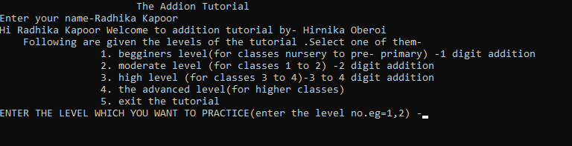

**If level is 1-**

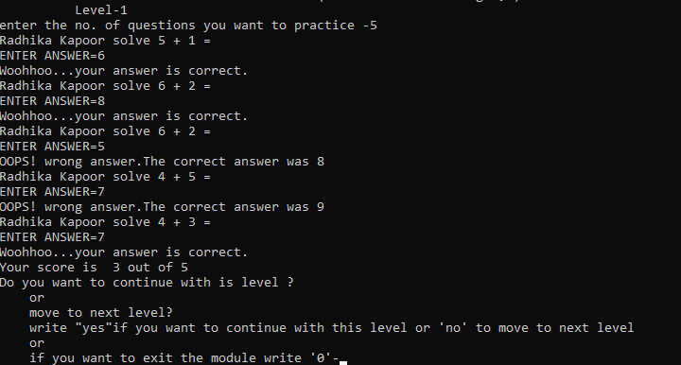

**If ‘yes’ is pressed (you continue with the same level)-**

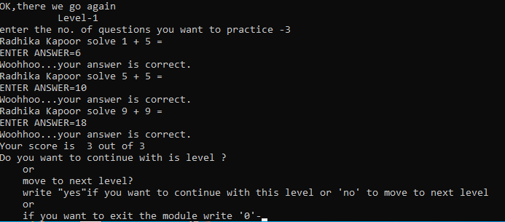

**If ‘no’ is pressed ( you are moved to next level)-**

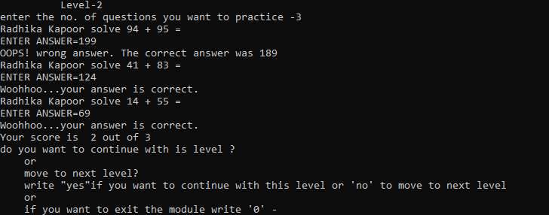

**If ‘0’ is pressed (module is ended)-**



**If level is 2-**

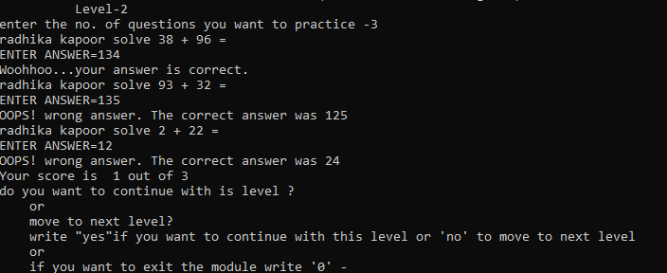

**If ‘yes’ is pressed (you continue with the same level)-**

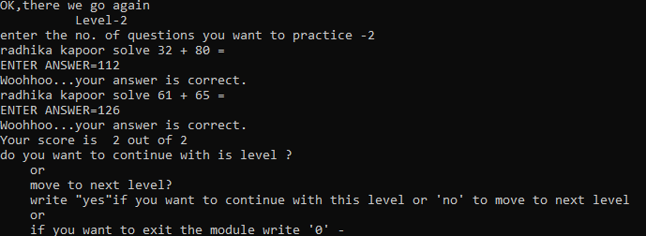

**If ‘no’ is pressed ( you are moved to next level)-**

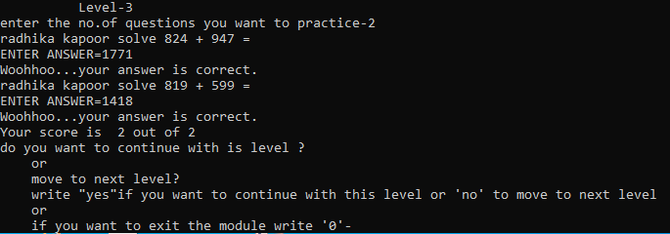

**If ‘0’ is pressed (module is ended)-**



**If level is 3-**

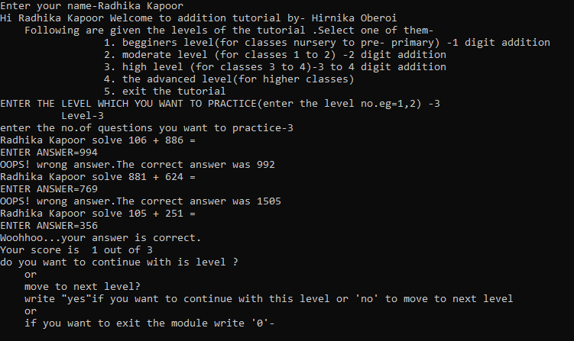

**If ‘yes’ is pressed (you continue with the same level)-**

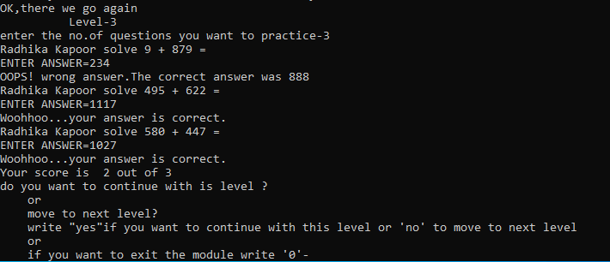

**If ‘no’ is pressed ( you are moved to next level)-**

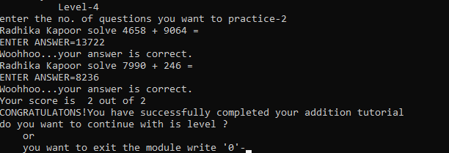

**If ‘0’ is pressed (module is ended)-**



**If level is 4-**

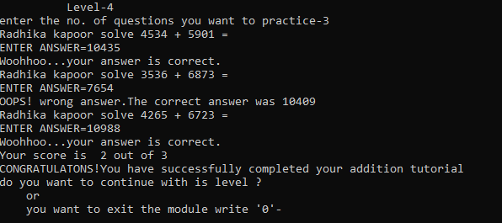

**If ‘yes’ is pressed (you continue with the same level)-**

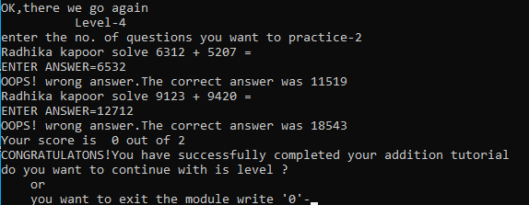

**If ‘0’ is pressed (module is ended)-**



**If level is 5-**

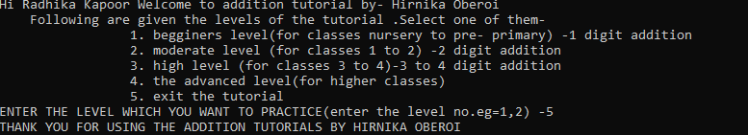

**OUTCOMES –**

1. This programme will help the students to perfect the addition skills of numerals upto ten lakh place at their own pace.
2. They will get to know the correct or incorrect answer on the spot.
3. They will be awarded marks on the basis of their performance at the end of each level.
4. They can practice as many as questions they want at their own convenience.
5. I was successfully able to make python programme using basic functions. Eg.- for loop, if -else conditional statement.

**RESOURCES-**

* Python IDLE
* Computer Science NCERT for class 11.

**AKNOWLEDGEMENT –**

I am grateful to Madam Sangita Panchal for giving, me the opportunity to enhance the skill of programming using

python language**.**

**Prepared by- Hirnika Oberoi**